**Computer Engineering -CSC 7011**

**Prof. Stephen Taylor**

**Arnika Vishwakarma (@01367603)**

**LAB REPORT- 09**

**Title: To write a assembly language program to compute a square roots**.

**Purpose:**

* The purpose of thus lab is to understand and write code in assembly language for square root.

**Requirements:**

* MPLAB Simulator.

**Description:**

**MPLAB Simulator–** MPLAB SIM is one of the debug engines that can be used with MPLAB. MPLAB SIM has features to simulate hardware interaction with other signals and devices, and since it is running as software on the PC, it has complete information about the internal state of the simulated chip at each instruction.

**SCHEMATIC DESIGN CODE:**

After working for more than 4 days in lab we developed the assembly language program using MPLAB.

**Step 1:** Creating a new schematic, click **File/family- 32-bit MCUS(PIC32), Device: PIC32MX110F0168, Select tool- simulator.**

**Step 2:** Below is the code for square root:

/*

#include <xc.h>

#define IOPORT_BIT_7 (1 << 7)

.global sqrt /* define all global symbols here */

/* .text

/* define which section (for example "text")

* does this portion of code resides in. Typically,

* all your code will reside in .text section as

* shown below.

*/

/* .set noreorder

/* This is important for an assembly programmer. This

* directive tells the assembler not to optimize

* the order of the instructions as well as not to insert

* 'nop' instructions after jumps and branches.

*/

/*********************************************************************

* main()

* This is where the PIC32 start-up code will jump to after initial

* set-up.

********************************************************************/

/*.ent main /* directive that marks symbol 'main' as function in the ELF

* output

*/

/*sqrt:

/* Call function to clear bit relevant to pin 7 of port A.

* The 'jal' instruction places the return address in the $ra

* register.

*/

/*li $a0, 0x00000004

add $a1,$zero,$zero

add $a2, $zero, $zero

li $s0,0x00000000

add $v0, $zero, $zero

newton:

add $a1, $zero, $a0

add $a2, $zero, $a0

jal divide:

ori a0, $0, IOPORT_BIT_7

jal mPORTAClearBits

nop

/*endless:

j endless

nop

.end main /* directive that marks end of 'main' function and its

* size in the ELF output

*/

/*********************************************************************

* mPORTAClearBits(int bits)

* This function clears the specified bits of IOPORT A.

*

* pre-condition: $ra contains return address

* Input: Bit mask in $a0

* Output: none

* Side effect: clears bits in IOPORT A

********************************************************************/

/*.ent mPORTAClearBits

mPORTAClearBits:

/* function prologue - save registers used in this function

* on stack and adjust stack-pointer

*/

/*addiu sp, sp, -4

sw s0, 0(sp)

la s0, LATACLR

sw a0, 0(s0) /* clear specified bits */

/* function epilogue - restore registers used in this function

* from stack and adjust stack-pointer

*/

/*lw s0, 0(sp)

addiu sp, sp, 4

/* return to caller */

/*jr ra

/*nop

.end mPORTAClearBits*/

/* n implementation of a fixed point computation of

reciprocal using 32bit Q16.16 fixed bit numbers.

The code finds x such that 1/x - D = 0 using Newton's method:

x_{n+1} = x_n (2 - x_n D)

which is a simplification of x_{n+1} = x_n - (1/x_n -D)/(-1/x^2)

The first approximation x_0 is computed

by using the position of the leading one

bit relative to the binary point. The approximate reciprocal is

a one bit which is reflected around bit 16 (which is the position of

the value one in Q16.16 fixed point) from the position of the highest one.

Stephen Taylor

November 4, 2016

*/

.equ BPfollows, 0x10 # position of binary point; only tested for value 16

#include <p32xxxx.h>

.global main /* define all global symbols here */

.text

/* define which section (for example "text")

* does this portion of code resides in. Typically,

* all your code will reside in .text section as

* shown below.

*/

.set noreorder

/* This is important for an assembly programmer. This

* directive tells the assembler not to optimize

* the order of the instructions as well as not to insert

* 'nop' instructions after jumps and branches.

*/

/*********************************************************************

* main()

* This is where the PIC32 start-up code will jump to after initial

* set-up.

********************************************************************/

/* all macro arguments for times should be register names */

/* multiply source1 by source2 and store result in dest */

/* where all are in Q16.16 format, with the integer part in the high

sixteen bits and the binary fraction in the low sixteen bits.

The macro actually assumes Q(32-BPfollows).(BPfollows)

but only the value 16 is tested.

*/

.macro times dest source1 source2

.set noat #disable assembler use of $at so I can use it here

mult \source1,\source2

mfhi \dest

sll \dest,\dest,BPfollows

mflo $at

srl $at,(0x20-BPfollows)

and $at,(1<<BPfollows)-1

or \dest,$at

.set at # reenable assembler use of $at

.endm

#push and pop macros

.macro push reg

addi $sp,$sp,-4

sw \reg,0($sp)

.endm

.macro pop reg

lw \reg,0($sp)

addi $sp,$sp,4

.endm

.ent main /* directive that marks symbol 'main' as function in the ELF

* output

*/

main:

push $ra

# first a little test scaffold

main1:

jal recipTest

nop

jal sqrtTest # test sqrt

nop

# test quadform

li $a0,0x10000

li $a1,0x30000

li $a2,0x20000

/*jal quadform*/

nop

b main1

nop

# this return is just extra baggage...

pop $ra

jr $ra

nop

recipTest:

push $ra

li $a0,0x1ffff

jal frecip

nop

pop $ra

jr $ra

nop

sqrtTest:

push $ra

nop

li $a0,0x10000 # sqrt should be 1.0, 0x10000

jal sqrt

nop

li $a0,0x20000 # 2. sqrt should be 17xxx?

jal sqrt

nop

li $a0,0x190000 # 2. sqrt should be 17xxx?

jal sqrt

nop

li $a0,0x90000 # 2. sqrt should be 17xxx?

jal sqrt

nop

li $a0,0x30000 #3. sqrt should be 1Bxxx?

jal sqrt

nop

pop $ra

jr $ra

nop

/* compute reciprocal in Q16.16 format.

description of algorithm above

argument in $a0

reciprocal returned in $v0 -- used as xn in the algorithm

$v1 is used as xn1

$t0, $t1, $t8 used as temporary variables, clobbered

*/

frecip:

# check for negative:

lui $t0,0x8000 # look for the leftmost 1 bit in $a0

and $t1,$a0,$t0

beqz $t1,fr1 #don't worry, it's positive

nop

move $t8,$ra # save return address, since jal changes it

jal fr1 # get reciprocal in $v0

sub $a0,$zero,$a0 # negate the negative number (this is delay slot

jr $t8 # return using saved return address

sub $v0,$zero,$v0 # negate the returned value (in delay slot)

fr1:

# check for zero -- which has no reciprocal

bnez $a0,fr2

lui $v0,0x7FFF # harmless if we branch; executed anyway. I broke li into

#lui, ori to load $v0 with one fewer instructions

# here if $a0 == 0. Return 0x7FFFFFFF,

ori $v0,0xFFFF # an approximation of positive infinity

jr $ra

nop

# find first approximation

fr2:

lui $t0,0x4000 #first non-negative bit

li $v0,4 # corresponding reciprocal

sub $v1,$zero,$zero # set up xn1 for fr4 loop now.

fr3:

and $t1,$a0,$t0 # found it yet?

bnez $t1,fr4 # found it

nop # don't put sll into delay slot ...

sll $v0,$v0,1

b fr3

srl $t0,$t0,1 # adjust (in delay slot)

fr4:

# this is the newton-raphson loop

# xn1 = xn * (2 - $a0 * xn)

times $t0,$v0,$a0

lui $t1,0x2 # this will be 2.0 in Q16.16 format. Would

sub $t0,$t1,$t0 # have to be fixed if BPfollows changed.

times $v0,$t0,$v0

bne $v0,$v1,fr4 #loop until $v0 == $v1

add $v1, $zero, $v0 #use add instead of move to fit delay slot

jr $ra # done, answer in $v0

nop

sqrt:

move $t6,$ra

move $a3,$a0

# this is the newton-raphson loop

# xn1 = (xn + $a3 * $v0) * 1/2

lui $a1,0x1

s1:

move $a0,$a1

jal frecip

nop

times $t7,$v0,$a3

add $t7,$t7,$a1

li $t8,0x8000

times $t7,$t7,$t8

bne $t7,$a1,s1 #loop until $v0 == $v1

add $a1, $zero, $t7 #use add instead of move to fit delay slot

jr $t6 # done, answer in $v0

nop

.end main

**DEBUGGING THE CODE:**

* **Reset** the target, in order to restart the application
* **Execute** the code so the program can be tested to verify it functions as designed
* **Halt** the code at breakpoints
* While halted at breakpoints, **examine and modify memory and variables** to analyze and debug the application code.

**OUTPUT IMAGE:**

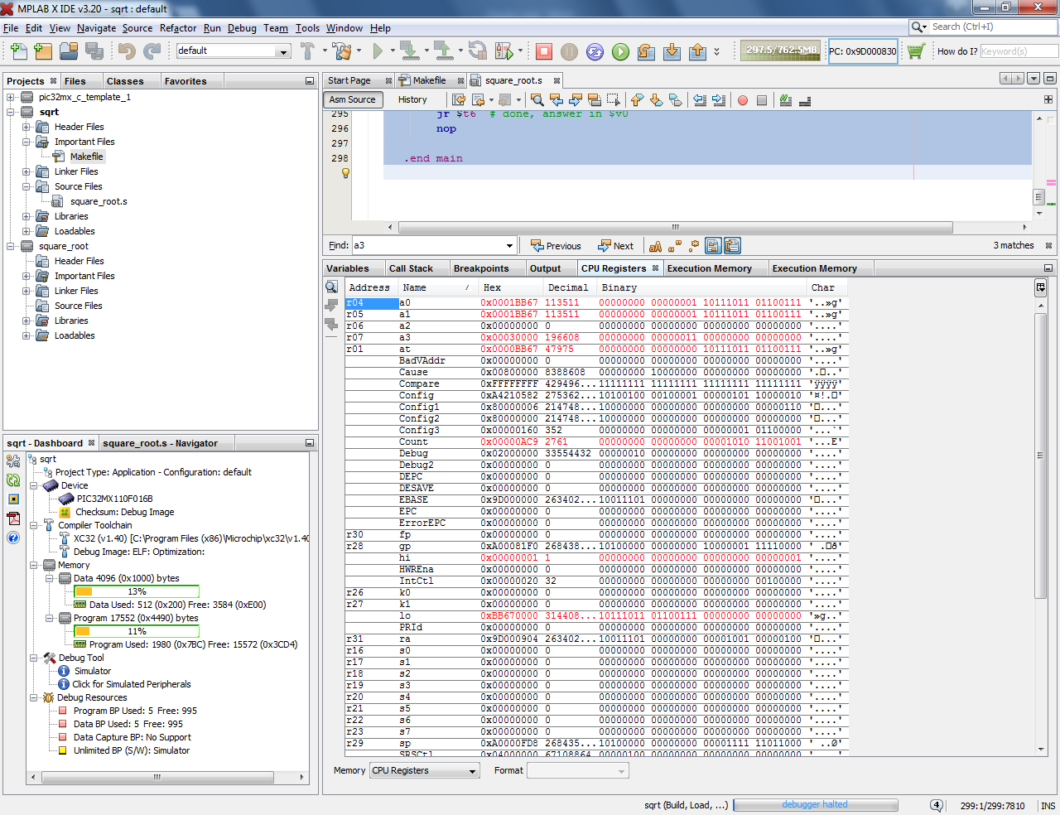

**Fig.1. Square root of 3**

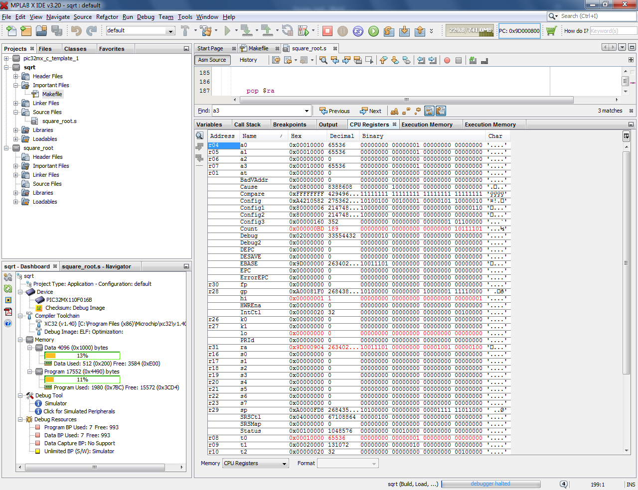

**Fig.2 Square root of 1**